**LIT ASSIGNMET-DAY 9**

**NAME: CHIKATI LIKHITHA**

**EMPLOYEE ID: 46255243**

**BATCH NAME: SAP ABAP-25**

**Exercise 1 – Table Enhancement Using Append Structure**

**Hints:**

1. Cannot be added in more than one table.
2. Append structures cannot be added to a table whose last field has data type LCHAR or LRAW.

**Requirement:**

**Append custom fields ZZDISCOUNT1 to ZZDISCOUNT5 in the standard table SFLIGHT.**

This table is used to store flight details such Flight Date, Airfare, Maximum capacity in economy class, and Occupied seats in economy class for an airline carrier and needs to be enhanced to store discounts available for each flight if applicable.

**Transaction –** Use your own T-code like ZYP01…ZY to display data.

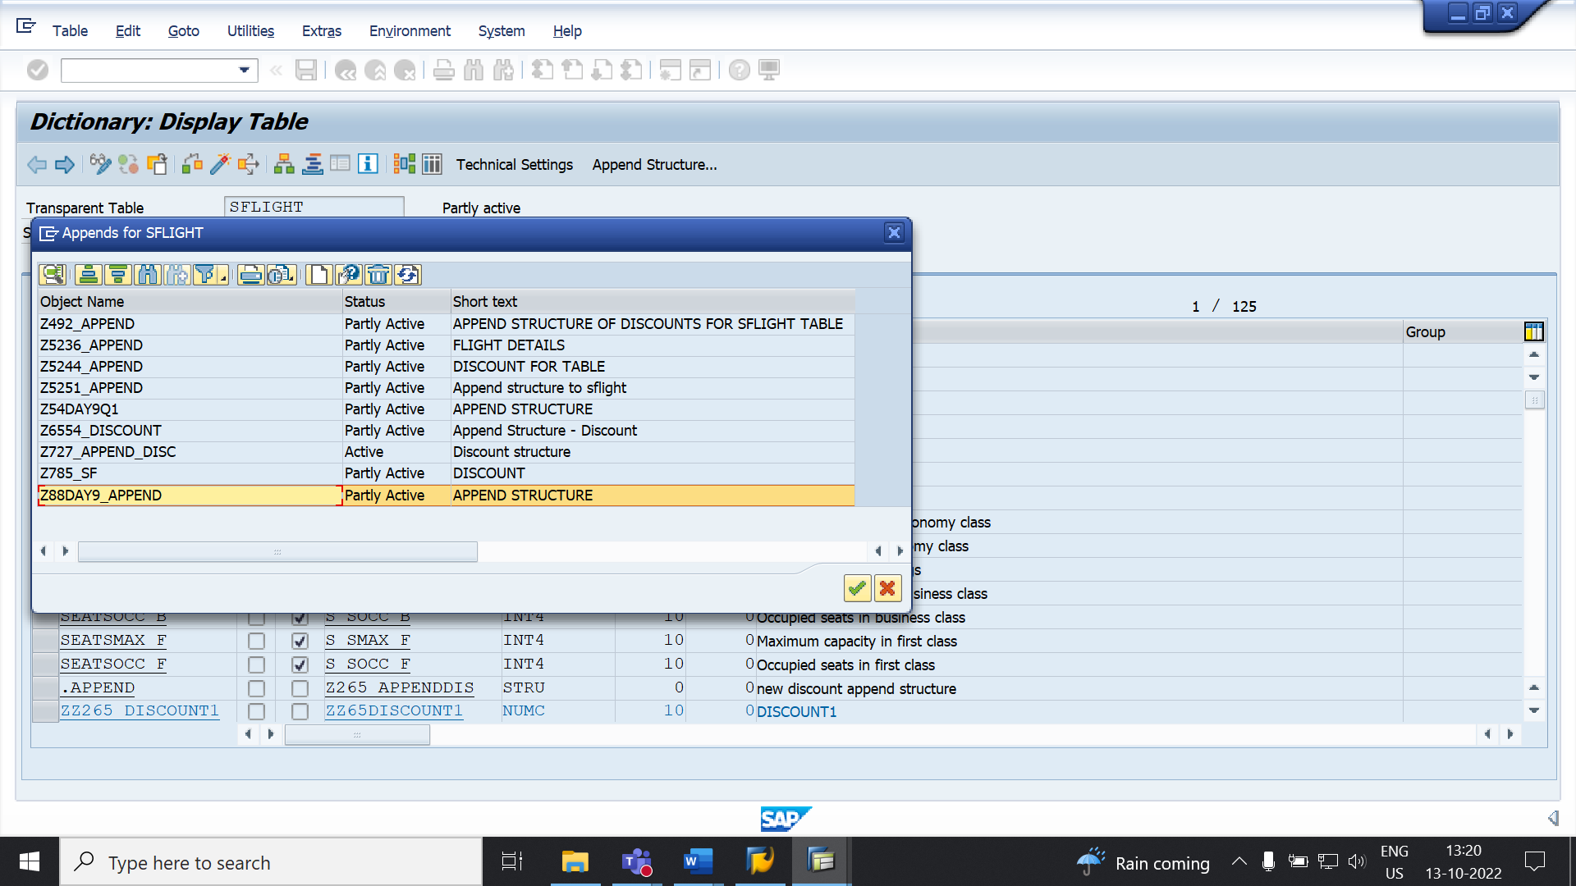

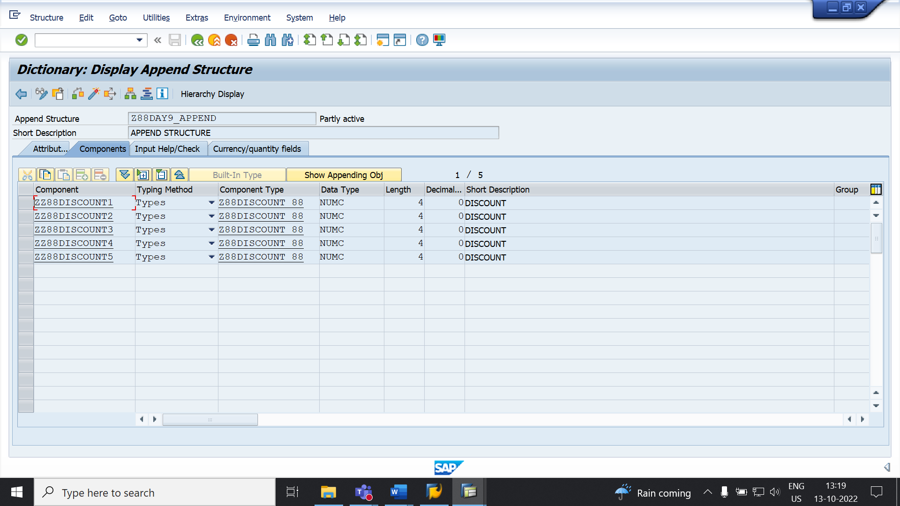

**Exercise 2 – Table Enhancement Using Customizing Include**

**Hints:**

1. Preplanned by SAP and provided in standard sap tables to add custom fields.
2. Can be available in more than one table, as these are planned by SAP.
3. These include are part of custom exits.

**Requirement:**

**Append custom fields ZZNAME1 to ZZNAME5 in the standard table EKKO *using* customizing include if available.**

This table is used to store purchase order details, which needs to be enhanced to store usernames that create the purchase orders.

**Transaction –** ME21N, ME22N & ME23N is used to create, change or display purchase orders.

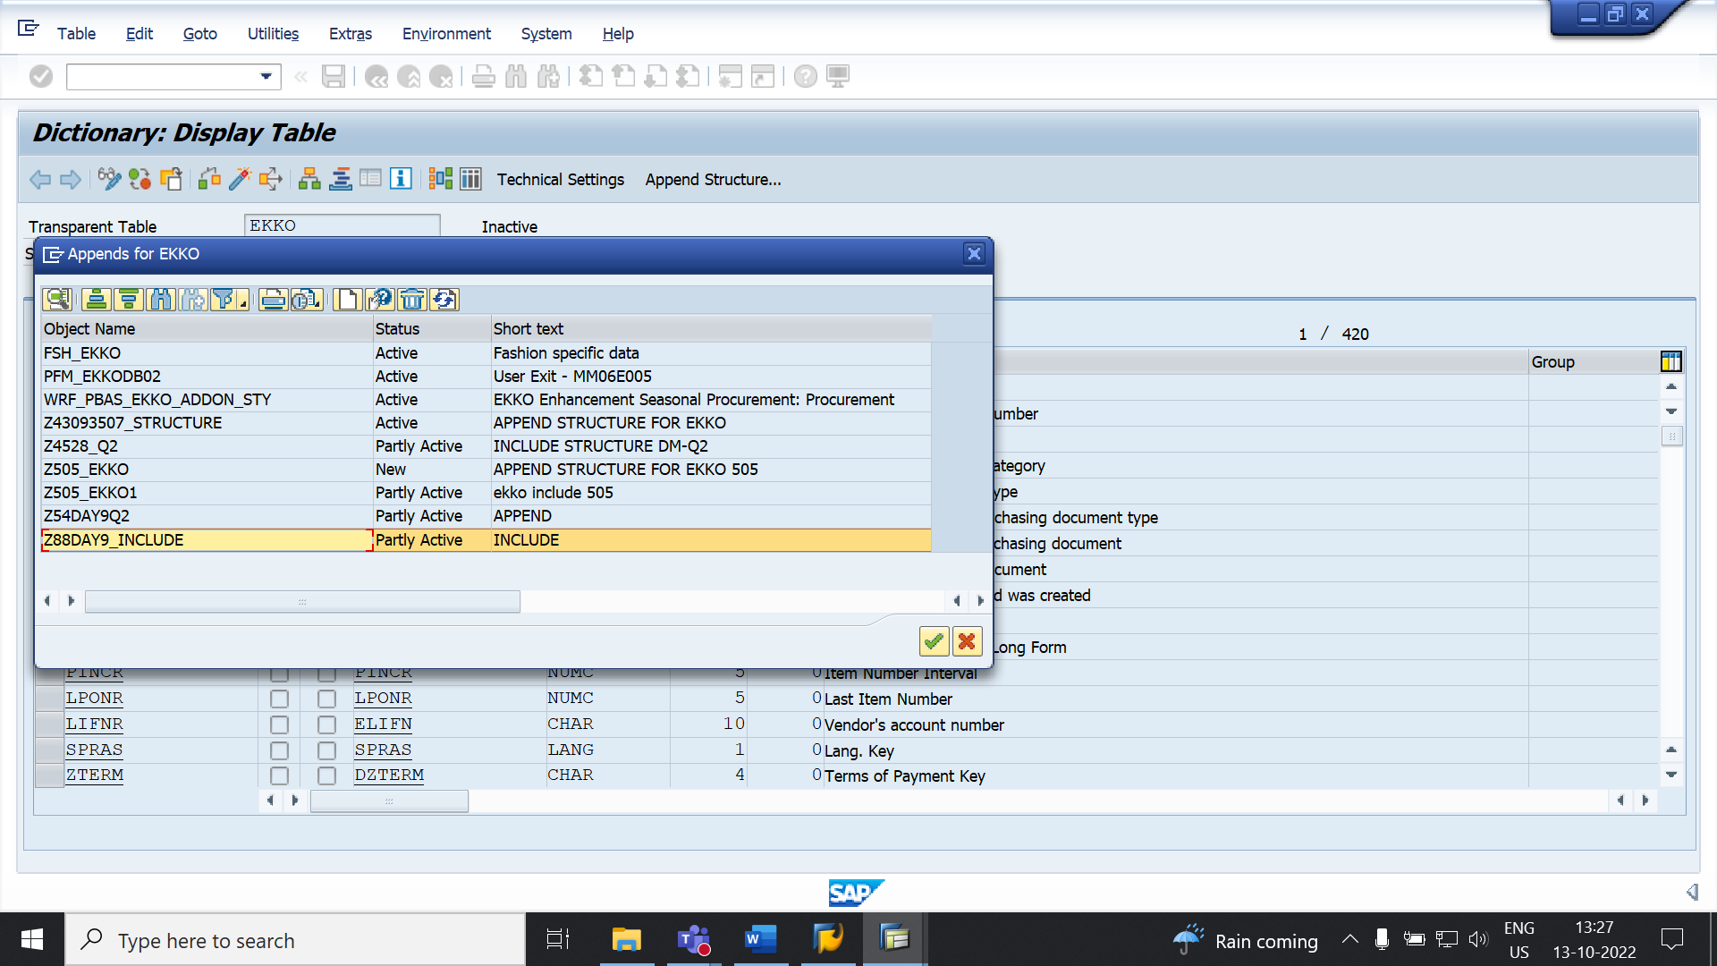

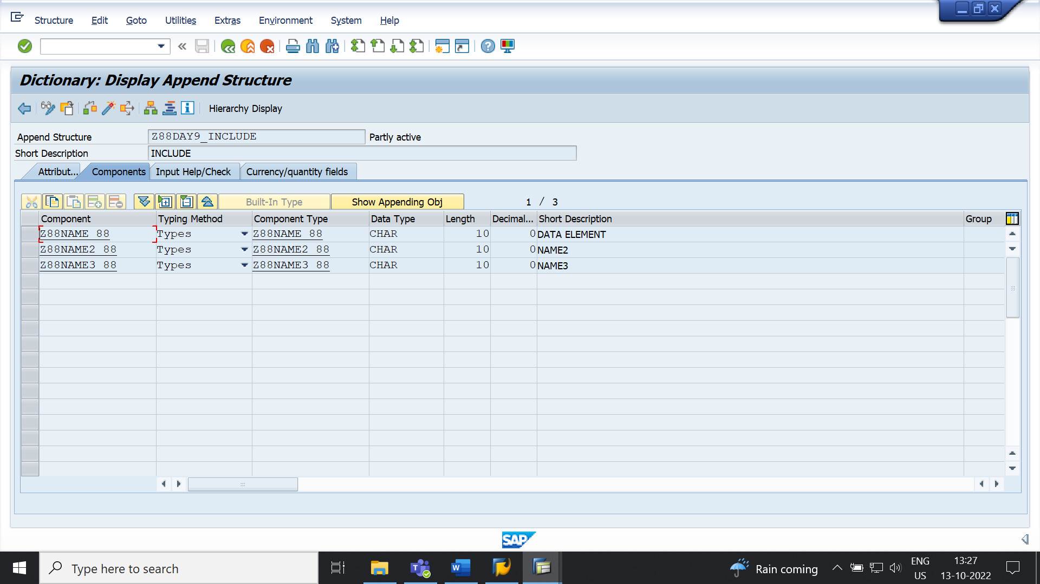**Exercise 3 – Text Enhancements**

**Hints:**

1. These are global enhancements, and these changes are visible in all transactions where these data elements are used.
2. You can restore sap or customer versions of field labels after upgrades
3. Execute transaction CMOD.
4. For Field Label - Navigate to ->Goto->Text enhancements->Keywords->Change
5. For Documentation - Navigate to ->Goto->Text enhancements->Data Elements->New Cust

**Requirement: Change field labels and documentation for transaction** ZYP01 **as requested by the end user who is using this transaction to maintain flight data.**

1. Airline Carrier should be renamed as Carrier Name.
2. Connection Number should be renamed as Flight Number.
3. Flight Data should be renamed as Carrier Date.
4. Airfare should be renamed Carrier Fare.
5. Plane Type should be named Carrier Type.

**STEP 1: Airline Carrier should be renamed as Carrier Name.**

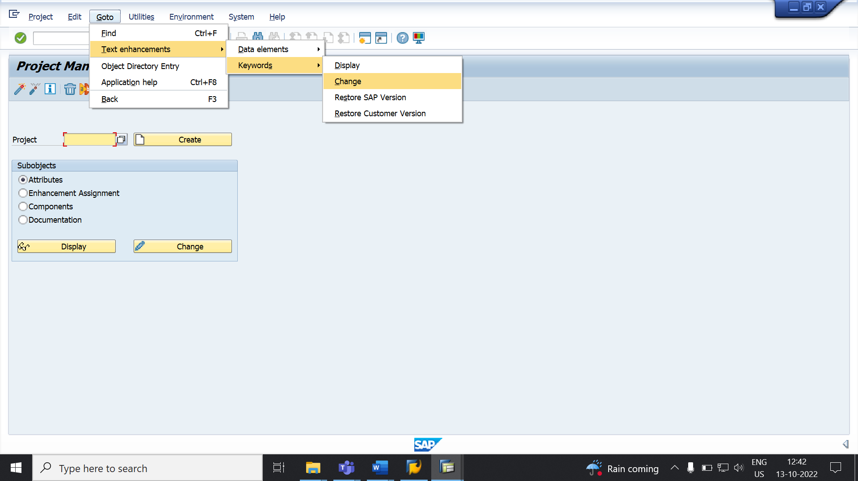

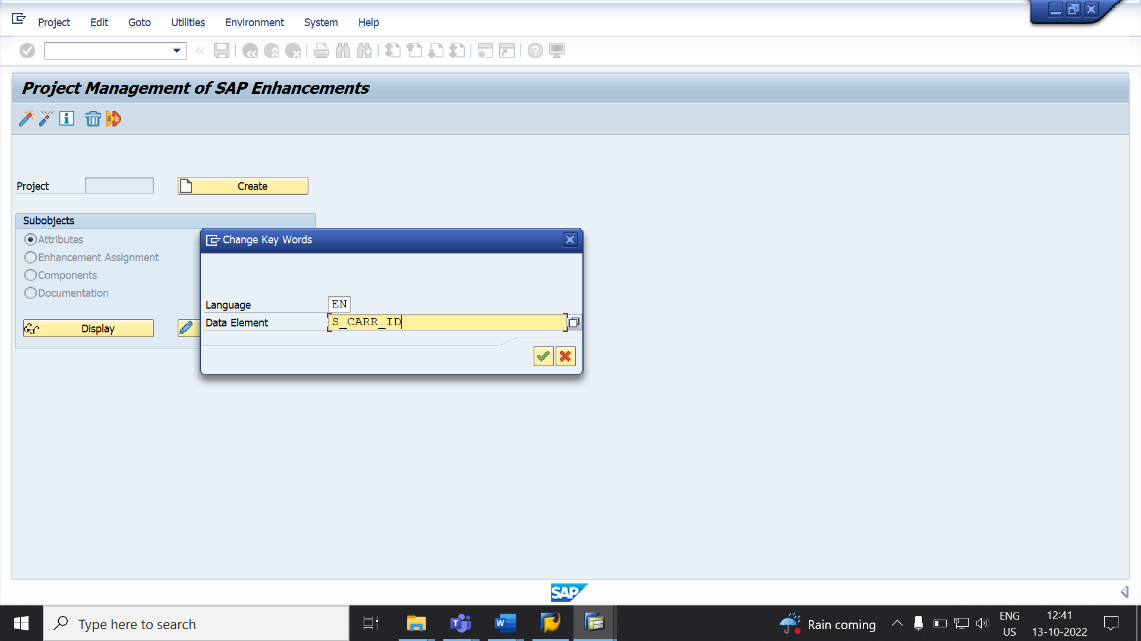

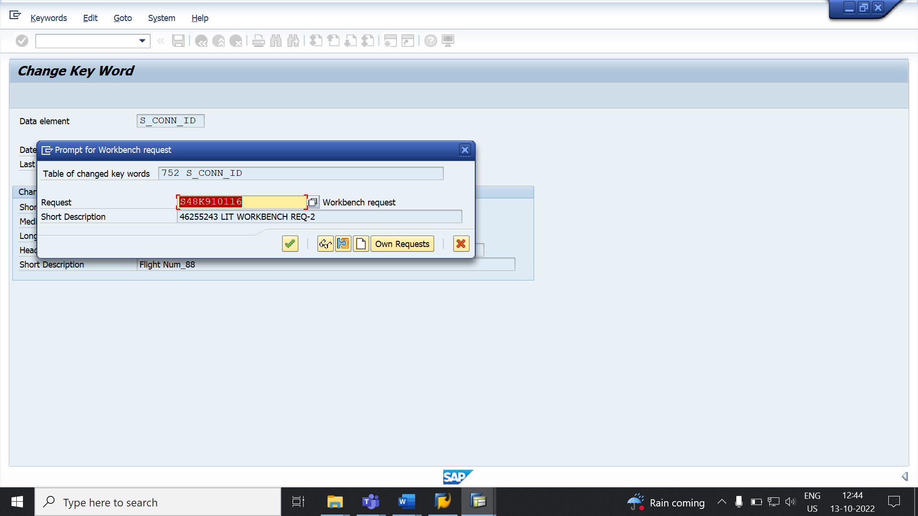

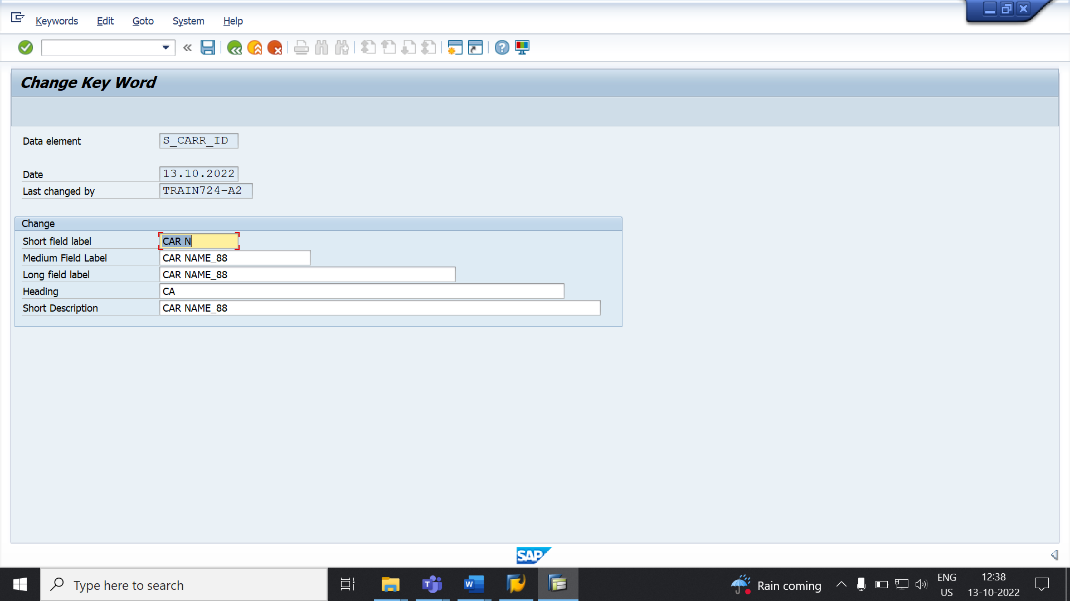

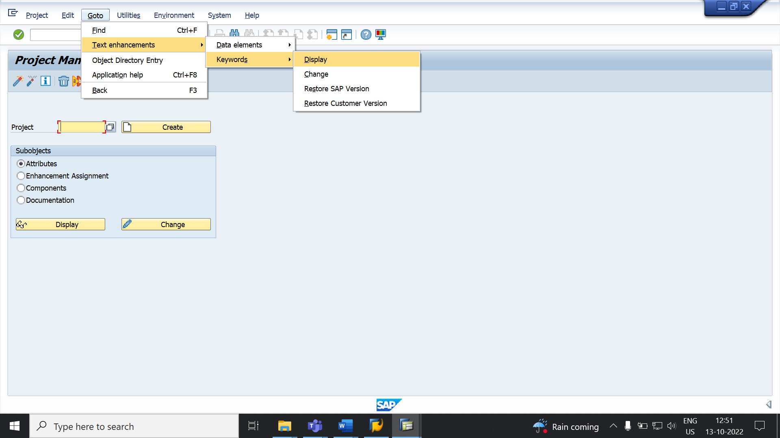

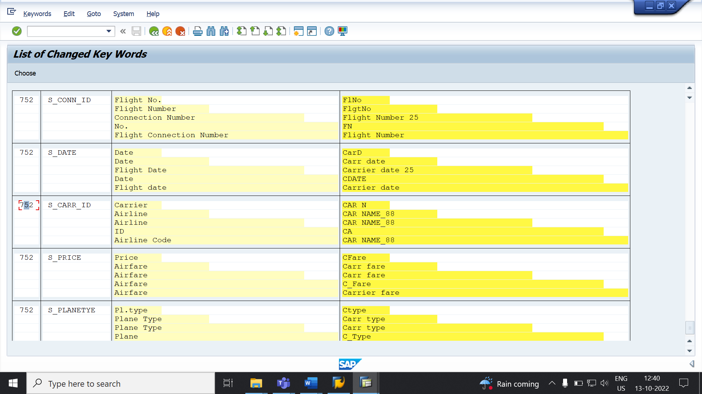

**STEP 2: Connection Number should be renamed as Flight Number.**

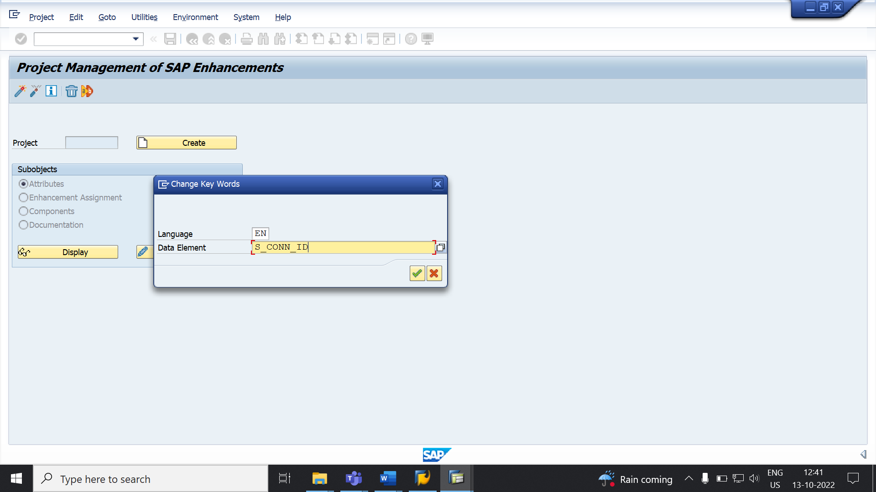

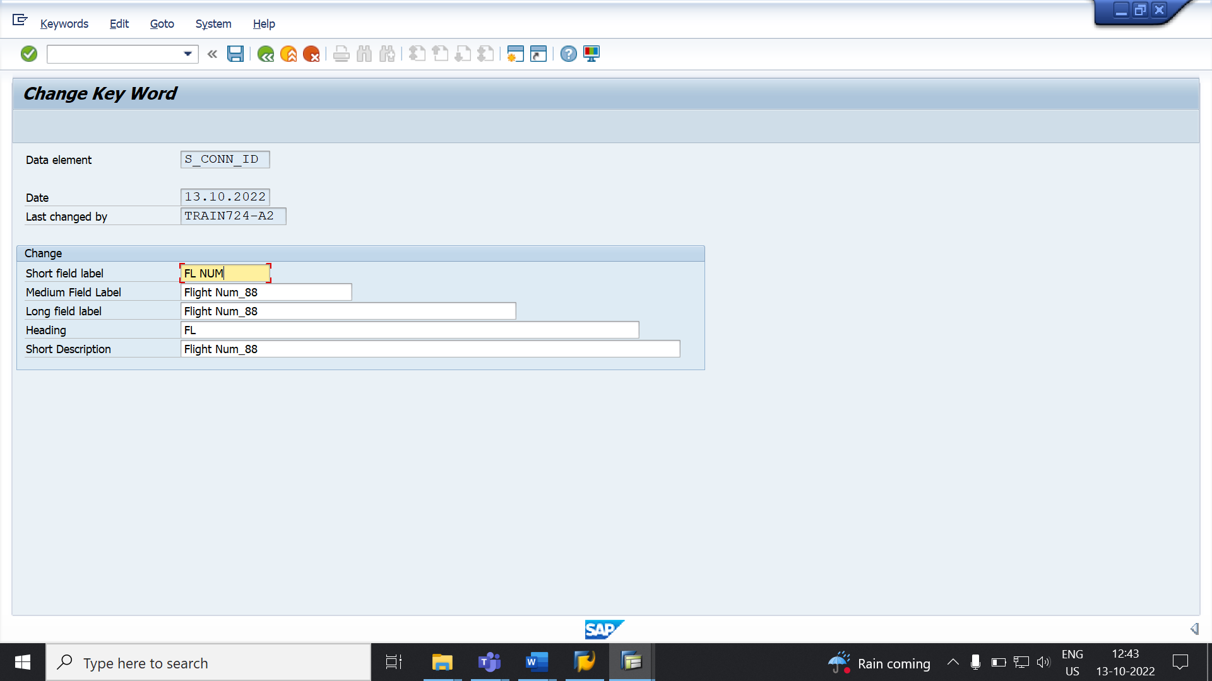

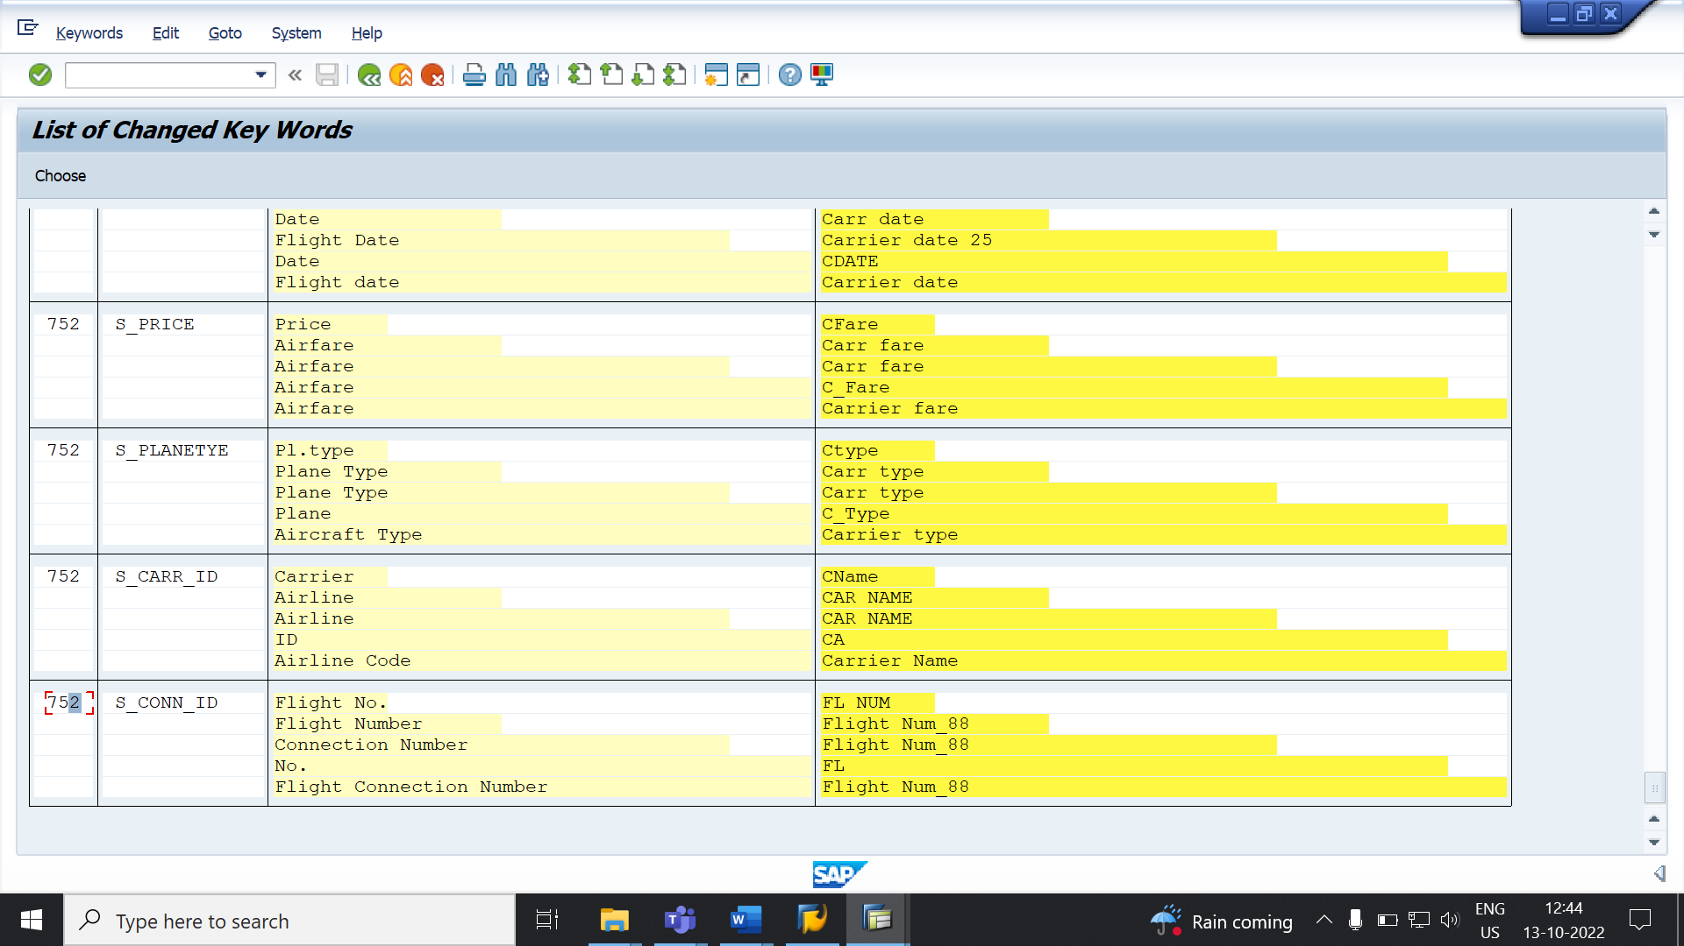

**STEP 3:** **Flight Data should be renamed as Carrier Date.**

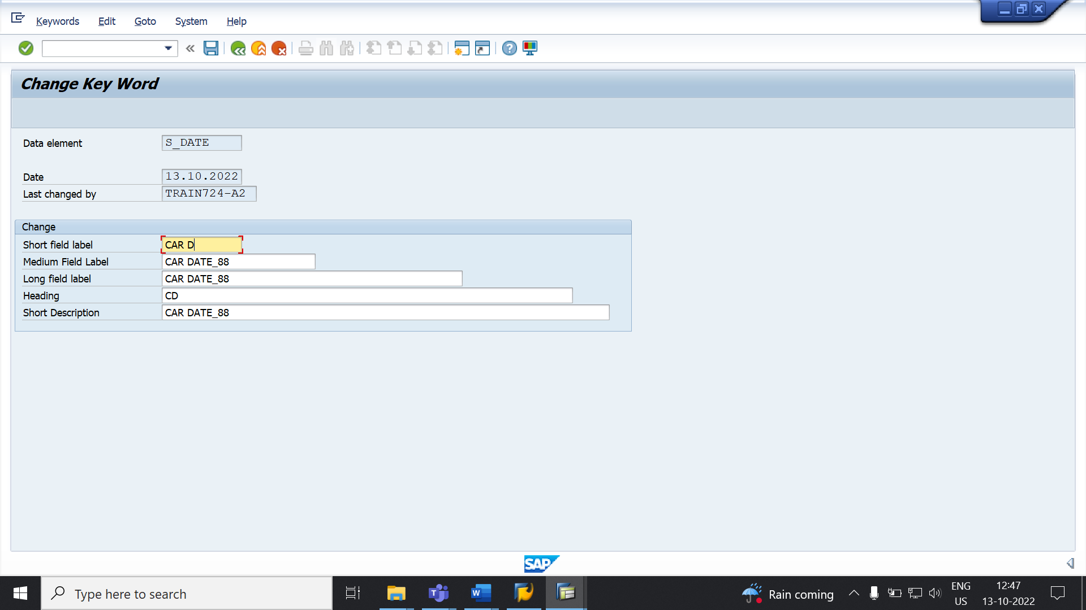

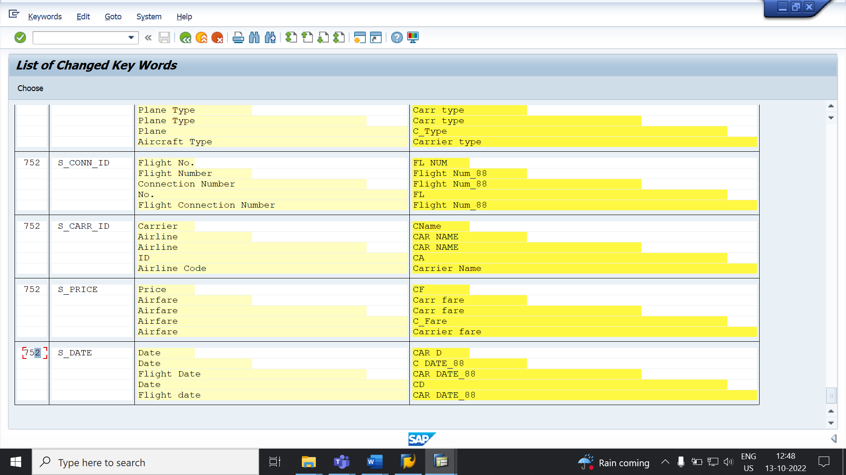

**STEP 4: Airfare** **should be renamed as Carrier Fare.**

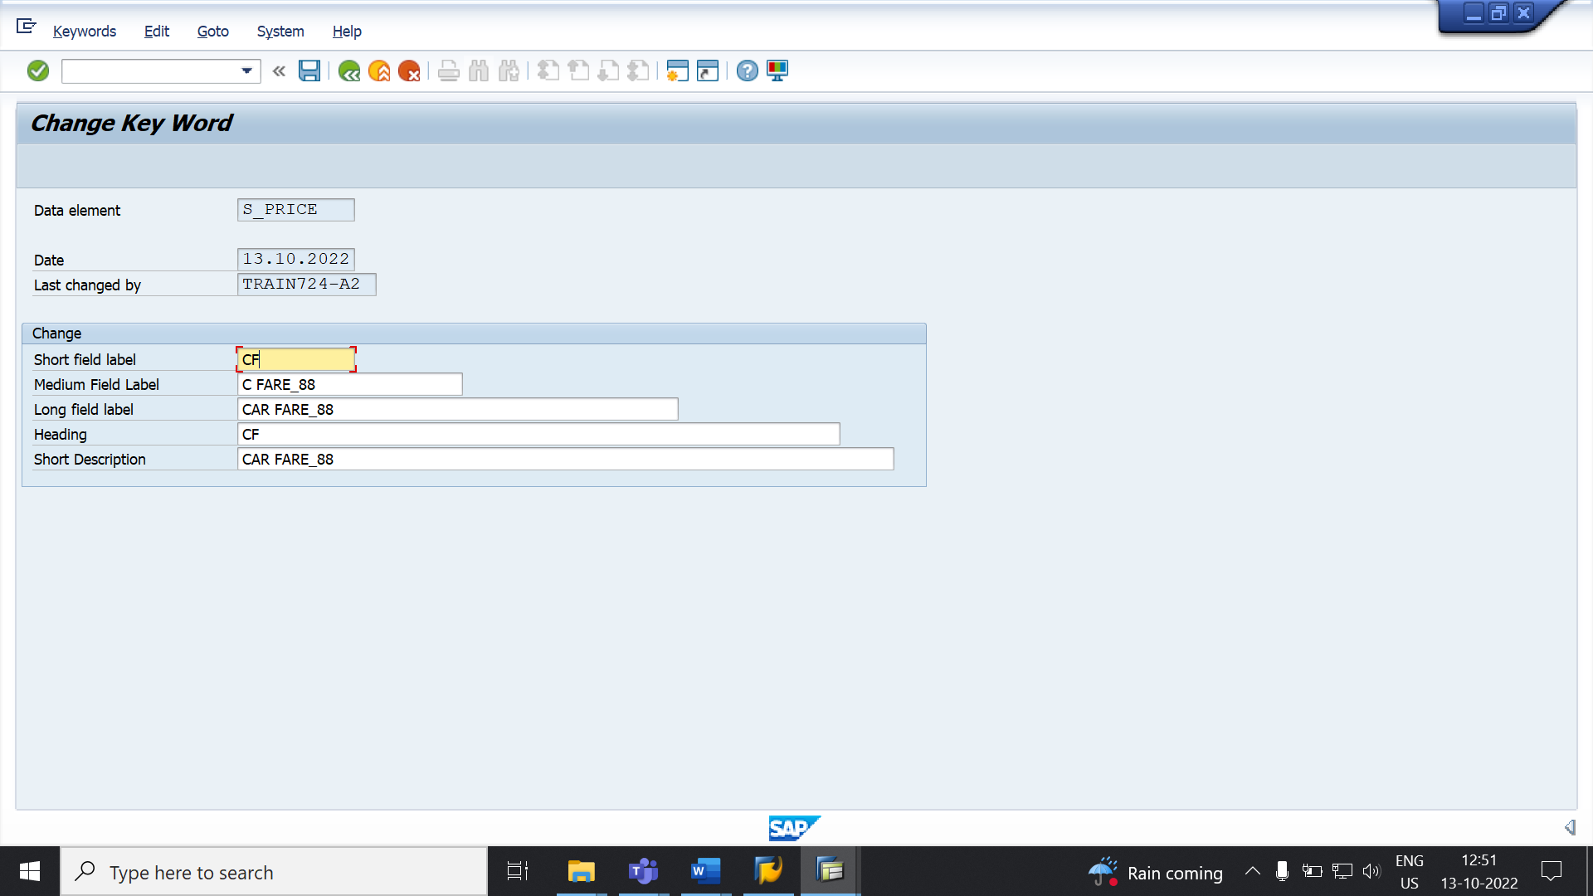

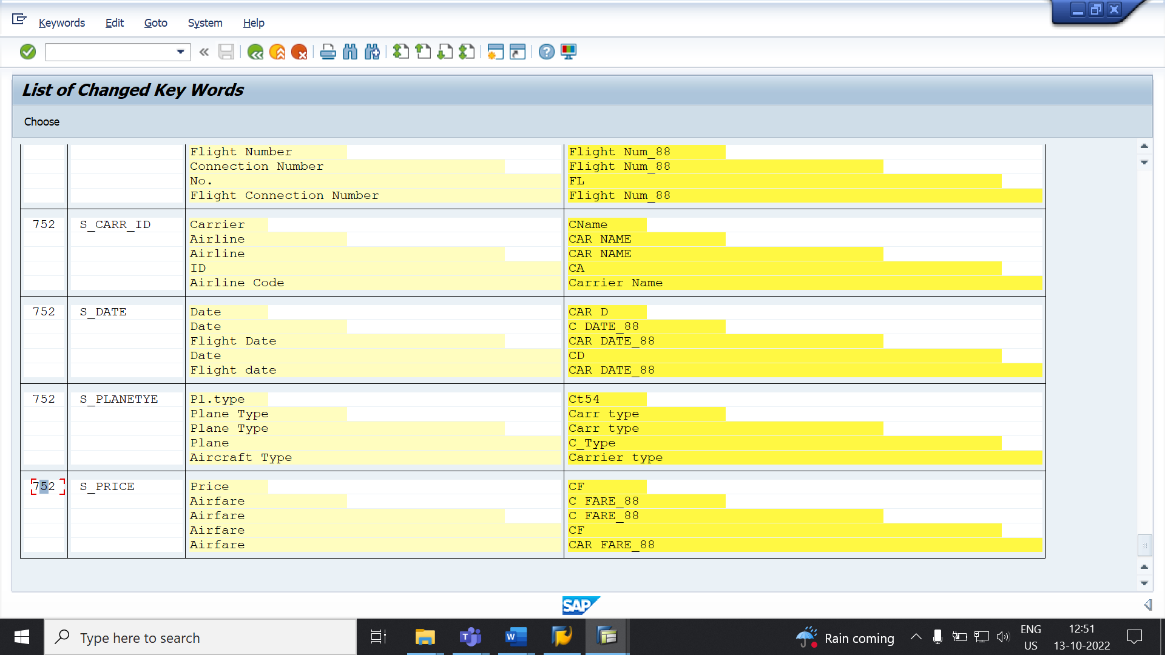

**STEP 5: Plane Type should be named as Carrier Type.**

